An
INTERNSHIP REPORT
On
EMBEDDED SYSTEMS + EDGE AI
Submitted in partial fulfillment of the requirements for the award of the degree of
BACHELOR OF TECHNOLOGY
in
ELECTRONICS AND COMMUNICATION ENGINEERING
by
K.Venkata kameswari
(Roll No. 23AK1A04F9)

Under the Mentorship of
S.THEJASWINI, M.Tech
Assistant Professor, ECE Department



DEPARTMENT OF ELECTRONICS AND COMMUNICATION ENGINEERING

ANNAMACHARYA INSTITUTE OF TECHNOLOGY AND SCIENCES, TIRUPATI
(AUTONOMOUS)

Approved by AICTE, New Delhi & Permanent Affiliation to JNTUA, Anantapuramu.
Five B .Tech Programmes (ECE, CSE,EEE,CE,ME) are accredited by NBA, New Delhi.
Accredited by NAAC with 'A' Grade, Bangalore. Accredited by Institution of Engineers (India)KOLKATA.
A-grade awarded by AP Knowledge Mission. Recognized under sections 2(f) & 12(B) of UGC Act 1956.
Venkatapuram (V), Renigunta (M), Tirupati, Tirupati District, Andhra Pradesh – 517520.
2025-26

ANNAMACHARYA INSTITUTE OF TECHNOLOGY AND SCIENCES, TIRUPATI
(AUTONOMOUS)
DEPARTMENT OF ELECTRONICS AND COMMUNICATION ENGINEERING

CERTIFICATE
This is to certify that Ms. K.Venkata kameswari (23AK1A04F9) has carried out Virtual Internship on “EMBEDDED SYSTEMS + EDGE AI” and submitted to the Department of ELECTRONICS AND COMMUNICATION ENGINEERING of Annamacharya Institute of Technology and Sciences, in partial fulfilment of the requirements for the award of the Degree of Bachelor of Technology in Electronics and Communication Engineering is meeting the Academic Regulations.

Signature of Internship Mentor Signature of HOD-ECE

DECLARATION

I am K.Venkata kameswari (23AK1A04F9), Studying Final year B. Tech in ELECTRONICS AND COMMUNICATION ENGINEERING of Annamacharya Institute of Technology and Sciences, hereby declare that this Internship report titled “EMBEDDED SYSTEMS + EDGE ” has been done by me. The Internship work carried out is original and has not been submitted to any other University or Institution for the award of any credits. I promise to meet all the mandatory requirements as specified by the Academic regulations.

PLACE:
DATE :
SIGNATURE

ACKNOWLEDGEMENTS

The needs and deeds of a particular person are only satisfied with the support and endurance of many.
I would like to express my deepest appreciation for All India Council for Technical Education, AICTE New Delhi for their commitment to the betterment of technical education and the opportunities they have made available to our students. I look forward to the continued collaboration between SkillDzire and APSCHE to provide more student Internships to gain hands-on experience and become better-prepared professionals.
I would like to extend my heartfelt thanks to Principal Dr. C. Nadhamuni Reddy for his constant encouragement and support during the Internship period.
I would like to express my heartfelt thanks to Dr. S. Rohini , Associate Professor and HOD, Department of ECE during the progress of Internship for his timely suggestions and help in spite of his busy schedule.
I would like to extend my heartfelt thanks to our department Internship Coordinator E. Satheesh Kumar, Assistant Professor, Department of ECE for providing consistent support for us to complete the course modules in order to complete my internship.
My heartfelt thanks to Internship mentor S.Thejaswini, M.Tech , Department of ECE for his/her valuable guidance and suggestions in analysis and testing throughout the period, till the end of Internship work completion.
Finally, I would like to express my sincere thanks to faculty members of ECE Department, Lab Technicians, Internship company trainers and friends, one and all that have helped me to complete the Internship successfully.

K.Venkata kameswari
Roll no.23AK1A04F9

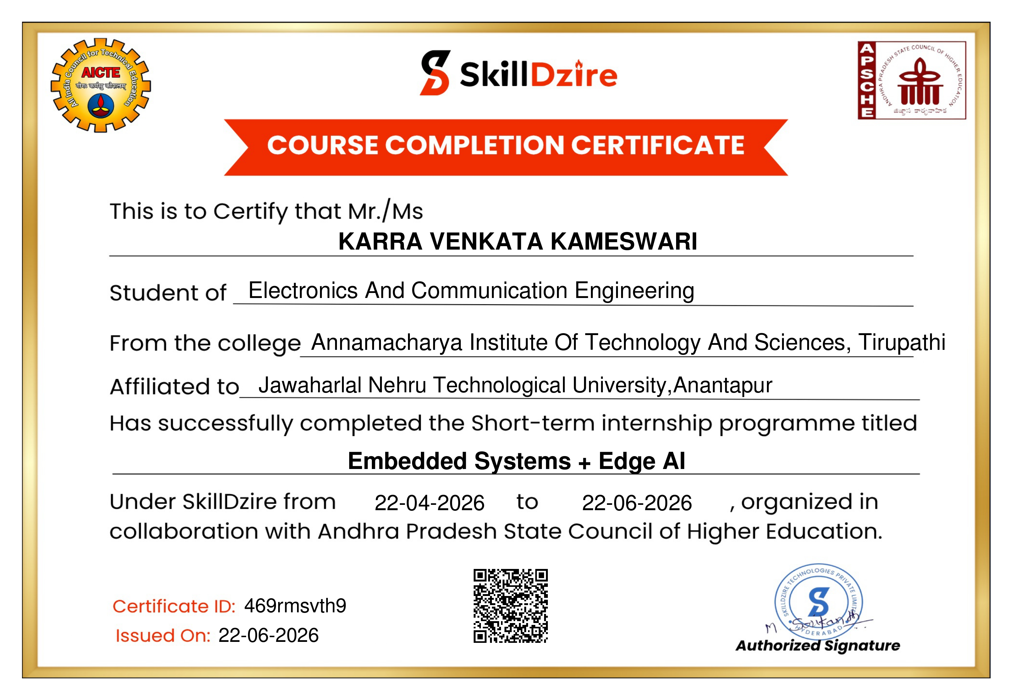

ABSTRACT

Embedded Systems and Edge Artificial Intelligence (Edge AI) are important technologies used in modern intelligent electronic systems. Embedded systems combine hardware and software to perform dedicated tasks using components such as microcontrollers, sensors, and communication interfaces. Edge AI enables AI-based data processing directly on embedded devices, allowing faster responses, reduced dependence on cloud servers, and improved privacy.
Embedded systems with Edge AI are widely used in applications such as IoT, robotics, healthcare, industrial automation, smart devices, and automotive systems. These systems can collect data from sensors or cameras, process it locally, and make intelligent decisions in real time. Developing such systems requires knowledge of programming, electronics, microcontrollers, communication protocols, and basic machine learning techniques.
The combination of Embedded Systems and Edge AI plays an important role in developing smart and autonomous applications. With the growth of IoT and intelligent automation, these technologies provide efficient solutions for real-time data processing and decision-making, making them valuable areas in modern electronics and engineering.

CONTENTS
Page No.
1 Chapter1 ……………………………………………………….….……….. 8
Introduction
2 Chapter 2 ………………………………………..……………….………... 9
Weekly Overview
3 Chapter 3 ………………………………………….……………………. 10
Modules
4 Chapter 4 …………………………………….…………………………. 19
Project
5 Chapter 5 ……………………………………..…...……………………. 27
Result and Conclusions
6 Chapter 6 …………………………………..……...……………………. 30
Verifiable Credentials

CHAPTER-1
INTRODUCTION

Introduction
The pursuit of knowledge and hands-on experience is a journey that takes aspiring engineers from theoretical learning into the practical world of technology. My learning experience in the field of Embedded Systems and Edge Artificial Intelligence (Edge AI) provided an opportunity to understand how hardware and software can be integrated to develop intelligent and real-time applications. This internship report presents my learning experience, covering the concepts, practical skills, and technologies explored during the internship.

The Importance of Academia-Industry Synergy
During the internship, I gained knowledge in areas such as microcontrollers, Embedded C programming, sensors, communication protocols, IoT, and Edge AI. I also explored the fundamentals of data processing and intelligent decision-making on embedded devices. The practical exposure helped me understand how embedded systems are designed, programmed, tested, and integrated with AI-based technologies for real-world applications.
The subsequent sections of this report describe the weekly activities, modules, practical learning, and project work completed during the internship. This experience helped strengthen my understanding of Embedded Systems and Edge AI while developing practical skills that are relevant to modern electronics, automation, IoT, and intelligent systems. The internship also provided valuable exposure to the application of engineering concepts beyond the classroom.

CHAPTER-2
WEEKLY OVERVIEW
Week 1-2 | Introduction to Embedded Systems + Edge AI  Microcontrollers, Sensors and Embedded Hardware
Week 3-4 | Embedded C Programming and GPIO  ADC, PWM, Timers and Interrupts
Week 5-6 | Communication Protocols – UART, I²C and SPI  Interfacing Sensors and Actuators
Week 7-8 | Introduction to Artificial Intelligence and Machine Learning  Data Collection and Pre-processing for Edge AI
Week 9-10 | Edge AI Concepts and Model Deployment  Real-Time Data Processing on Embedded Devices
Week 11-12 | IoT Connectivity and Embedded Communication  ESP32/Arduino-based Intelligent Applications
Week 13-14 | Mini Project on Embedded Systems and Edge AI  Implementation, Testing and Performance Analysis
Week 14-15 | Project Documentation and Final Project Submission

CHAPTER-3

MODULES

Introduction to Embedded Systems
Embedded systems are specialized computing systems designed to perform specific functions within larger electronic or mechanical systems. Unlike general-purpose computers, they are optimized for dedicated operations and consist of hardware and software working together to control, monitor, and process information.
Embedded systems are widely used in automobiles, home appliances, medical equipment, industrial machines, communication systems, consumer electronics, and IoT devices. Their development requires knowledge of microcontrollers, sensors, programming, communication protocols, and electronic circuits.

Characteristics of Embedded Systems
- Dedicated Functionality: Designed for a specific task or limited set of tasks.
- Real-Time Operation: Respond to external events within a specified time.
- Resource Constraints: Generally have limited processing power, memory, storage, and power.
- Reliability: Designed to operate continuously with proper hardware, software, and error handling.
- Low Power Consumption: Power-efficient operation is important, especially for battery-powered devices.

Microcontrollers and Embedded Hardware
A microcontroller is a compact integrated circuit containing a processor, memory, input/output interfaces, timers, and other peripherals. It acts as the main control unit of an embedded system by receiving input, processing it, and controlling outputs.

Major Components
- Microcontroller: Executes programs and controls peripherals.
- Memory: Stores programs and data using Flash, RAM, and sometimes EEPROM.
- Input Devices: Sensors, switches, and buttons provide information.
- Output Devices: LEDs, displays, buzzers, motors, and other actuators provide results.
- Power Supply: Provides stable and suitable voltage to the system.

Tools and Techniques
Microcontroller development boards, breadboards, jumper wires, sensors, LEDs, displays, motors, servo motors, power supply modules, and USB programming interfaces are commonly used.

Embedded C Programming
Embedded C is used to develop software for microcontrollers and embedded devices. It combines C programming concepts with hardware-specific operations and allows control of GPIO, timers, ADC, communication interfaces, and interrupts.

Basic Programming Concepts
- Variables and Data Types: Store information according to memory and range requirements.
- Conditional Statements: if, else, and switch are used for decision-making.
- Loops: for, while, and do-while repeat instructions.
- Functions: Divide programs into reusable sections.
- Arrays: Store multiple values of the same data type.
- Pointers: Provide direct access to memory addresses and are important in low-level programming.

GPIO Programming
GPIO pins connect the microcontroller with external devices. They can be configured as inputs for sensors and switches or outputs for LEDs, buzzers, and other devices.

Arduino and ESP32 Development
Arduino development boards provide a simple platform for learning embedded programming and hardware interfacing. The Arduino IDE is used to write, compile, and upload programs.
The ESP32 is a microcontroller platform with Wi-Fi, Bluetooth, GPIO, ADC, PWM, timers, interrupts, UART, I²C, and SPI. These features make it suitable for IoT, robotics, automation, and intelligent embedded applications.

Practical Applications
ESP32 can be used in:
- IoT devices
- Sensor monitoring
- Home automation
- Robotics
- Wireless control systems
- Smart devices
- Edge computing applications

Sensors and Actuators
Sensors collect information from the environment and convert physical quantities into electrical signals. Actuators perform physical actions based on control signals from the embedded system.

Types of Sensors
- Temperature Sensors: Measure surrounding temperature.
- Ultrasonic Sensors: Measure distance using reflected ultrasonic waves.
- Motion Sensors: Detect movement.
- Light Sensors: Detect light intensity.

Types of Actuators
- DC Motors: Convert electrical energy into rotational motion.
- Servo Motors: Provide controlled angular movement.
- LEDs: Provide visual indications.
- Buzzers: Generate audio signals for alerts.

Analog-to-Digital Conversion and PWM
An ADC (Analog-to-Digital Converter) converts continuously varying analog signals into digital values that can be processed by a microcontroller.
PWM (Pulse Width Modulation) controls average power by rapidly switching a digital signal. It is commonly used for LED brightness, motor speed, and servo control.

Applications
- Sensor measurement
- Temperature monitoring
- Light intensity measurement
- LED brightness control
- Motor speed control
- Servo motor control

Interrupts and Timers
Interrupts allow a microcontroller to temporarily stop normal execution and respond to an important event such as a button press, sensor event, communication data, or timer event.
Timers are hardware peripherals used to measure time intervals and generate periodic events. They are useful for scheduling, pulse generation, motor control, and real-time applications.

Communication Protocols in Embedded Systems
Communication protocols allow microcontrollers, sensors, and modules to exchange information. The major protocols studied include UART, I²C, and SPI.

UART
UART is an asynchronous serial communication protocol commonly used between two devices. It uses transmit and receive lines and is widely used for debugging and module communication.

I²C
I²C is a synchronous protocol using SDA for data and SCL for clock. Multiple devices can share the same bus using individual addresses. It is commonly used with sensors, OLED displays, and RTC modules.

SPI
SPI is a synchronous high-speed communication protocol. It commonly uses clock, data-in, data-out, and chip-select signals and is used with displays, memory, and sensors.

Introduction to IoT
The Internet of Things (IoT) refers to physical devices that collect, process, and exchange data through communication networks. Embedded systems provide an important foundation for IoT applications.

IoT Components
- Sensors
- Microcontrollers
- Communication modules
- Network connectivity
- Data processing
- Cloud or edge platforms
- User interfaces

Applications
IoT is used in smart homes, industrial monitoring, agriculture, healthcare, environmental monitoring, smart energy systems, and security systems.

Introduction to Edge AI
Edge AI refers to processing artificial intelligence tasks close to where data is generated instead of sending all data to a remote cloud server. It can reduce communication requirements and provide faster responses.

Advantages of Edge AI
- Low Latency: Reduces delay caused by remote processing.
- Reduced Network Dependency: Certain operations can work without continuous cloud connectivity.
- Privacy: Less raw data needs to be transmitted externally.
- Real-Time Processing: Suitable for applications requiring rapid responses.
- Efficient Data Processing: Only important results may need to be transmitted.

Edge AI and Embedded Devices
Combining embedded systems with AI allows devices to perform intelligent operations using sensor data. An Edge AI system generally includes sensors, an embedded processor, and an AI model.

Basic Edge AI Workflow
Data Collection → Data Preprocessing → AI Model → Inference → Decision → Action
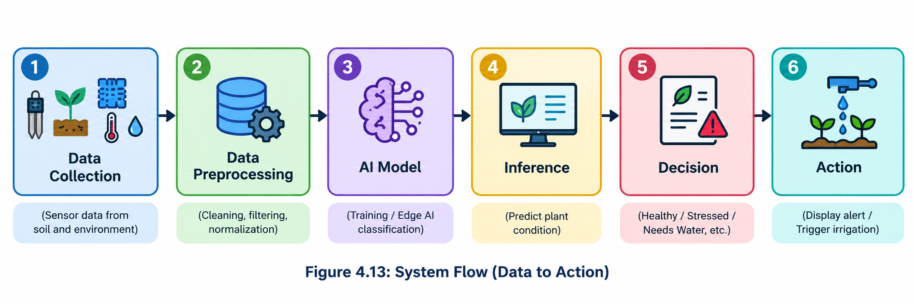
Applications include smart cameras, intelligent robots, predictive maintenance, object detection, voice-enabled devices, industrial automation, smart agriculture, and intelligent IoT systems.

Data Collection and Processing
Sensors continuously collect information from the environment. The collected data may contain noise or unwanted variations, so preprocessing is performed before further analysis or AI processing.

Data Processing Techniques
- Data filtering
- Noise reduction
- Normalization
- Feature extraction
- Data formatting
- Sampling
Proper data processing improves the quality of information used for analysis and decision-making.

Embedded System Testing and Debugging
Testing and debugging ensure that hardware and software work together correctly. Debugging identifies and corrects errors, while testing verifies that the system meets its required specifications.

Common Testing Activities
- Checking power connections
- Testing GPIO signals
- Verifying sensor readings
- Testing communication interfaces
- Checking actuator operation
- Monitoring serial output
- Testing different operating conditions

Debugging Techniques
- Serial Monitor
- Debug messages
- Hardware inspection
- Sensor output verification
- Step-by-step program testing
- Connection verification

Embedded Systems Applications
Embedded systems and Edge AI are used in many industries:
- Automotive Systems: Monitoring and controlling vehicle functions.
- Industrial Automation: Monitoring machines and controlling processes.
- Healthcare: Supporting medical equipment and monitoring parameters.
- Consumer Electronics: Used in appliances, wearables, cameras, and entertainment systems.
- Robotics: Combining microcontrollers, sensors, motors, communication, and intelligent algorithms.
- Smart Agriculture: Monitoring environmental conditions and supporting automated operations.

Practical Implementation of Embedded and Edge AI Systems
Development begins by identifying a problem and selecting suitable hardware and software. The microcontroller is programmed, sensors collect information, and actuators perform required actions. For intelligent applications, sensor data can be processed locally using an AI model to make decisions.

Development Process
- Problem Identification – Define the real-world problem and required functionality.
- Hardware Selection – Select the microcontroller, sensors, actuators, communication modules, and power supply.
- Circuit Development – Connect components and verify electrical connections.
- Software Development – Write and upload the embedded program.
- Sensor Interfacing – Connect and test sensors for reliable input.
- Actuator Control – Control motors, LEDs, displays, and other outputs.
- Communication – Implement UART, I²C, SPI, Wi-Fi, or Bluetooth as required.
- Testing and Debugging – Test under different conditions and correct errors.
- Edge AI Integration – Process data locally and apply an AI model where required.
- Final Demonstration – Verify the complete system and demonstrate its functionality.

CHAPTER-4
PROJECT

EDGE AI BASED SMART PLANT HEALTH MONITORING SYSTEM

4.1 Introduction
The Edge AI Based Smart Plant Health Monitoring System is a proposed embedded system for monitoring plant conditions using soil moisture, temperature, and humidity sensors. An ESP32 collects and processes the sensor data to determine the condition of the plant.
The system performs initial processing locally using Edge AI instead of depending completely on a remote server. It can classify conditions such as normal, water required, or unsuitable environmental conditions.

4.2 Objectives
The main objectives are:
- Monitor soil moisture, temperature, and humidity.
- Use ESP32 as the main processing unit.
- Process sensor data locally.
- Apply Edge AI for plant-condition classification.
- Provide alerts or monitoring results.
- Provide a foundation for automatic irrigation and smart agriculture.

4.3 Technical Architecture
The system consists of sensors, ESP32, data processing, Edge AI, and output devices.
The sensors collect soil moisture, temperature, and humidity data. The ESP32 processes these values, and a lightweight Edge AI model can classify the plant condition. The result can be displayed through an OLED, LED, or buzzer. A relay and water pump can be added for automatic irrigation.
Architecture:
Plant Environment → Sensors → ESP32 → Data Processing → Edge AI → Plant Condition → Output

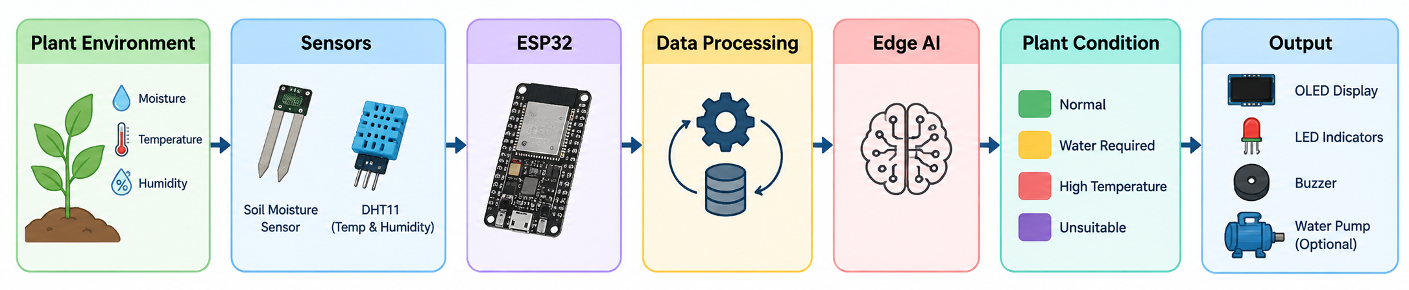
Fig :Technical Architecture

4.4 Hardware Components

4.4.1 ESP32
Acts as the main controller, processing sensor readings and controlling output devices.

4.4.2 Soil Moisture Sensor
Measures the moisture level of the soil and provides an analog signal to the ESP32.

4.4.3 DHT11 Sensor
Measures the surrounding temperature and humidity.

4.4.4 OLED Display
Displays sensor readings and plant-condition information.

4.4.5 LED and Buzzer
Provide visual and audio alerts when required.

4.4.6 Relay and Water Pump
Optional components used for automatic irrigation.

4.5 Software Requirements
The required software includes:
- Arduino IDE
- ESP32 Board Package
- Embedded C/C++
- DHT sensor library
- OLED library
- Serial Monitor
- Basic Machine Learning / Edge AI model
The Arduino IDE is used to develop and upload the program to the ESP32.

4.6 System Flow
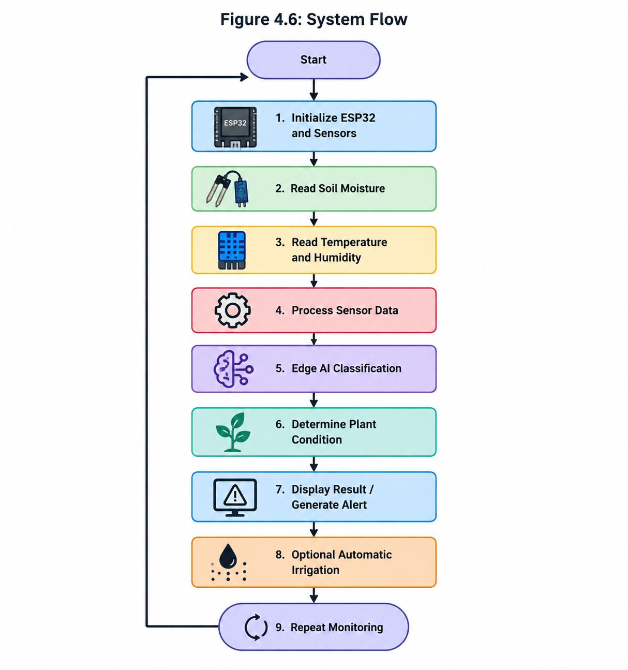

4.7 Edge AI Model
The ESP32 acts as the edge device. Sensor values such as soil moisture, temperature, and humidity can be provided as inputs to a lightweight classification model.
Possible output classes include:
- Normal Condition
- Water Required
- High Temperature
- Unsuitable Environmental Condition
The model can be trained using sensor data representing different environmental conditions and then deployed on a suitable embedded platform.

4.8 Development

4.8.1 Requirement Analysis
The system requires soil moisture, temperature, and humidity monitoring, local processing, plant-condition classification, user notification, and optional automatic irrigation.

4.8.2 Technology Selection
Technology | Purpose
ESP32 | Main controller
Embedded C/C++ | Programming
Soil Moisture Sensor | Soil monitoring
DHT11 | Temperature and humidity
OLED | Display
Edge AI | Local classification

4.8.3 Hardware Setup
The ESP32 is connected to the soil moisture and DHT11 sensors. OLED, LED, and buzzer can be connected as output devices. The sensors collect environmental information and the ESP32 performs the required processing.

4.8.4 Sensor Data Collection
The soil moisture sensor provides soil moisture information, while the DHT11 provides temperature and humidity values. The ESP32 periodically reads and processes these values before displaying or classifying the plant condition.
Note: Any serial-monitor values shown in the report should be identified as representative/expected outputs unless they were actually measured from the completed system.

4.9 Advantages
- Continuous plant-condition monitoring
- Reduced need for manual observation
- Low-cost embedded components
- Local processing using ESP32
- Edge AI-based classification
- Real-time alerts
- Option for automatic irrigation
- Possible IoT expansion

4.10 Applications
The proposed system can be applied to:
- Smart agriculture
- Home gardening
- Greenhouses
- Plant nurseries
- Smart irrigation
- Educational applications

4.11 Future Enhancements
The system can be extended with:
- Camera Module: For plant-leaf image analysis and disease detection.
- Automatic Irrigation: Relay and water pump controlled according to soil moisture.
- Mobile/Web Application: Remote monitoring using ESP32 wireless connectivity.
- Additional Sensors: Light intensity, soil temperature, and other environmental sensors.
- Advanced Edge AI: Classification of multiple plant conditions and intelligent recommendations.

4.12 Overall Development Flow

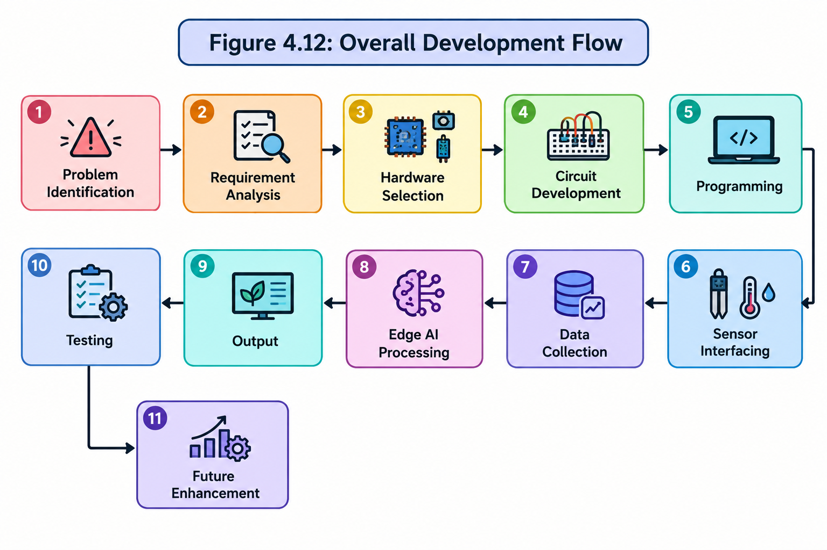
4.13 Conclusion
The Edge AI Based Smart Plant Health Monitoring System demonstrates the integration of embedded hardware, sensors, ESP32 programming, and Edge AI for plant monitoring. The system collects soil moisture, temperature, and humidity data and processes it locally to identify plant conditions.
The proposed system can be further enhanced with automatic irrigation, camera-based disease detection, IoT connectivity, and advanced Edge AI models, providing a foundation for intelligent smart-agriculture applications.

CHAPTER-5

Results and Conclusions

Result
- The proposed Edge AI Based Smart Plant Health Monitoring System was designed to demonstrate the integration of embedded systems, sensors, ESP32 programming, and Edge AI for plant-condition monitoring.
- The proposed system is designed to collect important environmental parameters such as soil moisture, temperature, and humidity and process the collected information using an ESP32 microcontroller.
- The project demonstrates how sensor data can be processed locally at the edge and used to identify conditions such as normal soil moisture, water-required conditions, and unsuitable environmental conditions.
- The project also provides a foundation for integrating an Edge AI classification model, allowing intelligent decisions to be made closer to the source of the collected data.
- The proposed system can be extended with an OLED display, LED or buzzer alerts, and a relay-controlled water pump for automatic irrigation.
- The project demonstrates the practical application of Embedded Systems and Edge AI in areas such as smart agriculture, home gardening, greenhouse monitoring, and intelligent irrigation.

Conclusions

Conclusion of the Virtual Internship
The internship has been a valuable and enriching learning experience, providing an opportunity to understand and apply concepts related to Embedded Systems and Edge AI. During the internship, I gained knowledge about microcontrollers, sensors, embedded programming, data processing, and the fundamentals of artificial intelligence at the edge.

Skill Development
The internship helped me develop and understand technical skills related to embedded system development. I gained knowledge of ESP32 programming, sensor interfacing, Embedded C/C++, data collection, and basic Edge AI concepts. The experience helped connect theoretical concepts learned during academics with practical applications.

Project Understanding
The development of the proposed Smart Plant Health Monitoring System helped me understand how different components of an embedded system work together. I learned how sensor data can be collected, processed, and used to generate meaningful decisions. The project also provided an understanding of how Edge AI can be integrated with embedded devices for local data processing.

Problem Solving and Adaptability
Working with embedded-system concepts helped improve my problem-solving abilities. Understanding the relationship between sensors, microcontrollers, software, and intelligent processing encouraged me to approach technical problems systematically. The internship also helped me understand the importance of adapting solutions according to project requirements.

Professional Growth
The internship provided valuable exposure to technologies that are relevant to modern embedded-system development. It improved my understanding of the relationship between hardware and software and gave me greater confidence in exploring areas such as IoT, Edge AI, automation, and smart-device development.

Future Scope
The proposed project can be further enhanced by integrating a camera for plant-image analysis, a more advanced Edge AI model for plant-condition classification, IoT connectivity for remote monitoring, and an automatic irrigation mechanism using a relay and water pump. These enhancements can make the system more intelligent and suitable for practical smart-agriculture applications.

Conclusion
In conclusion, the internship provided an opportunity to develop knowledge in Embedded Systems and Edge AI and understand their practical applications. The proposed Smart Plant Health Monitoring System demonstrated how sensors, an ESP32 microcontroller, local data processing, and Edge AI concepts can be combined to address a practical monitoring problem.
The internship not only improved my technical understanding but also strengthened my problem-solving, analytical, and practical learning abilities. The knowledge gained during this experience will provide a useful foundation for further learning and future projects in Embedded Systems, IoT, Artificial Intelligence, and Edge Computing.

CHAPTER-6
VERIFIABLE CREDENTIALS

Verifiable Link for Certificate
/home/karracharanteja/Downloads/SKILL DRIZZ.pdf
GitHub Repository Link
https//github.com/mizikdee/Keylogging.git
CODE QR


